**Design Details**

We have used:

1. ReactJS as the front-end for designing.
2. Firebase as the back end for storing the data.
3. Stripe for payment integration.

In this section the complete outline of the project will be described

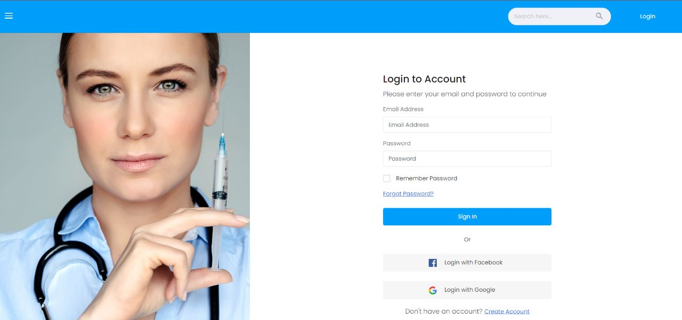

**Figure 1** Shows the Login and the registration page.

**Figure 2** Shows the Doctor Profile Page

**Figure 3** Shows the Patient scheduled appointment Page

**Figure 4** Shows the admin Dashboard page

**Figure 5** Shows the verified Patient List Page

**Figure 6** Shows the Notification page

**Figure 7** Shows the Latest updates page.

**Figure 8** Shows the Booking appointment with doctor page.



**Figure 9** Shows the Video calling and prescription page

**Figure 10** Shows the Patient report uploading and file view.

**Figure 11** Doctor receives the patient details after permission granted.

**Figure 12** Shows the Pharma shopping page.

**Figure 13** Shows various test procedures and tests available.

**Figure 14** Shows various health packages provided.

**Figure 15** Shows Nearby Lab locations based on co-ordinates.

**Figure 16** Shows Test Details and Lab Details.

**Figure 17** Shows Laboratory Testing New and Confirm Appointments.

**Figure 18** Shows Schedule Lab testing Details Patient Side.

**Figure 19** Shows the CART and payment.